Casework Services
Our Casework Services provides confidential, voluntary, short-term counseling for young people and their families who reside within the Hazel Park School District. This service is provided for a one time processing fee of $25.00 by our professional casework staff. Parents, school personnel, police officers, and concerned citizens may make referrals for services. Please call our office for a referral form or for more information.
Volunteers
Hazel Park Youth Assistance welcomes all citizens in our community who are interested, concerned and willing to give voluntarily of their time and skills to help serve, create and implement youth programs.
We are always looking for new volunteers! If you are interested in making a positive difference in the lives of our youth and families and in strengthening our community, join us at Hazel Park Youth Assistance.
Hazel Park Youth Assistance
(248) 582-9125

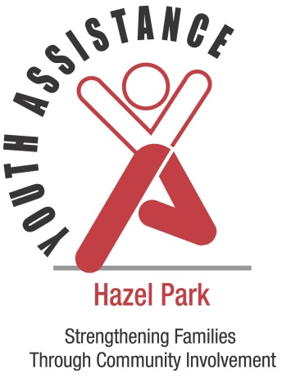

Committees and Programs

Camp
Camp scholarships are provided to young people residing within Hazel Park School District who are interested in a day camp, overnight camp or specialty camp experience. Some camps are in the community, while others require transportation. We offer scholarships for youth ages 5-16 whose families demonstrate a financial need.
Family Education
Hazel Park Youth Assistance offers a variety of programs aimed at improving communication between parents and their children, understanding child development, and enhancing parenting skills. The Family Education Committee plans and implements these important educational programs. Programs are offered throughout the school year to students, parents and the community members at minimal or no cost.
Student Enrichment
Hazel Park Youth Assistance provides scholarships to youth who would benefit from a learning experience outside of school. Involvement in extracurricular activities can help children gain self-confidence and social skills. Families are limited to one scholarship per child and are expected to contribute a small amount toward the cost.
Youth Recognition
Young people are recognized for making volunteer contributions to their communities. Nominations come from schools, churches, and the community members who have been helped by a youth. The youth are presented with a special award signed by local dignitaries. To nominate a child, please contact our office.

Purpose
- Mobilization of community interests, skills and forces on behalf of children and families.
- Involvement of local citizens in developing and improving services designed to control, treat, and eliminate and prevent delinquency, neglect and abuse.
- Identification of social, psychological, and environmental factors producing problematic behaviors.
- Creation of programs to assist families in developing skills which will decrease the likelihood of delinquency, neglect and abuse from occurring.
Organization
Hazel Park Youth Assistance has been serving the community since 1953 with volunteers who are assisted by our professional staff. Our volunteers and staff are concerned with challenges of the youth and families living in our community. We are 1 of 26 local Youth Assistance offices across Oakland County.
Meetings
Meetings of the Hazel Park Youth Assistance Board of Directors are conducted monthly. These are open meetings designed to implement educational and supportive programs for youth and families residing within the boundaries of Hazel Park School District. For information on the time and location of these monthly meetings, please contact our office at (248) 582-9125.

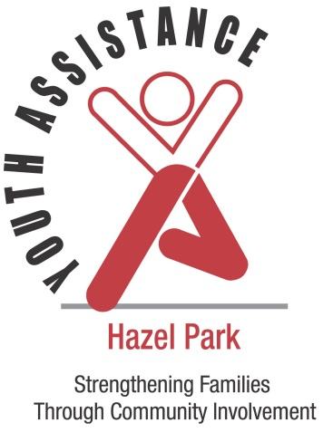
Hazel Park Youth Assistance Sponsors
The City of Hazel Park
The Hazel Park School District
The Oakland County Circuit Court-Family Division
Hazel Park Youth Assistance Supporters
Community Members
Local Businesses

************************************
Special thanks to the Hazel Park Fire Department for their continued support and dedication to Hazel Park Youth Assistance.
************************************

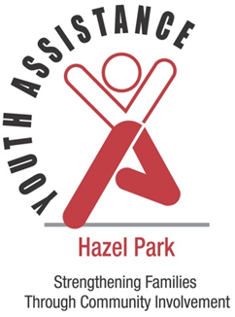

Hazel Park Youth Assistance
431 W. Jarvis
Hazel Park, MI 48030
(248) 582-9125

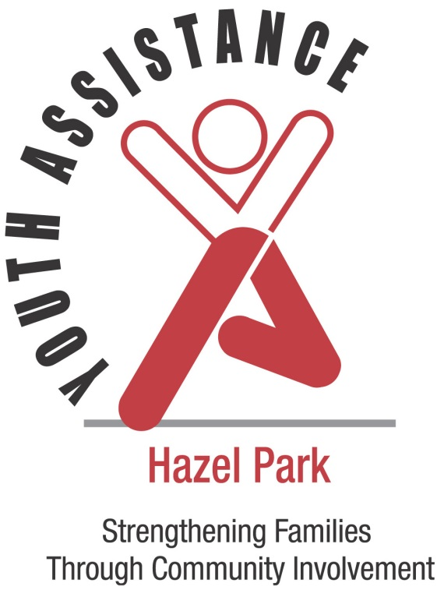

MISSION
To strengthen youth and families and prevent and reduce delinquency, neglect and abuse through community involvement

Hazel Park Youth Assistance
431 W. Jarvis
Hazel Park, MI 48030
(248) 582-9125

Serving Youth and Families Since 1953

